Cloud Data Lake Reference Architecture
Sample
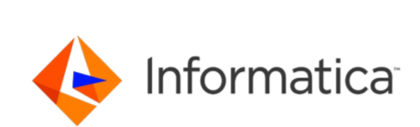

Business Reason to Maintain a Cloud Data Lake
As companies are realizing the real value data could bring to their business, they are tending to store and process “all” and “any” data available in their landscape. This data can be of any nature and over time can accumulate into petabytes. With the availability of cheaper storage options, companies can now choose to store all of this data without much of a cost burden to the business. It is also desirable to leverage native cloud processing capabilities while keeping the data within the data lake without needing to take it outside.

The Need for a Comprehensive Integration Platform
With a changing data landscape and data being dumped into data lakes, companies need to come up with a blueprint to combine a data warehouse and a cloud data lake for the cloud. Without the solid foundation of a cloud native data management solution, this architecture can become unstable and untrustworthy.
Informatica’s Integration Platform as a Service (iPaaS) is a cloud native enterprise data management solution that can ensure a successful implementation of a cloud data warehouse and cloud data lake architecture, eliminating the need to send data outside the platform to a separate transformation environment.

Cloud Data Lake Landscape and Architecture
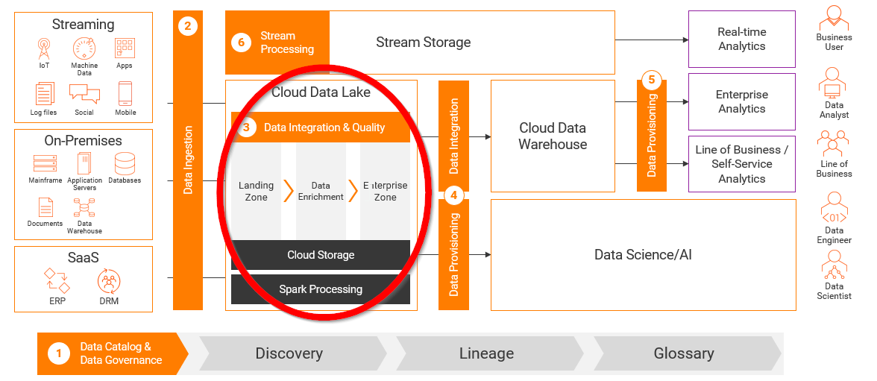

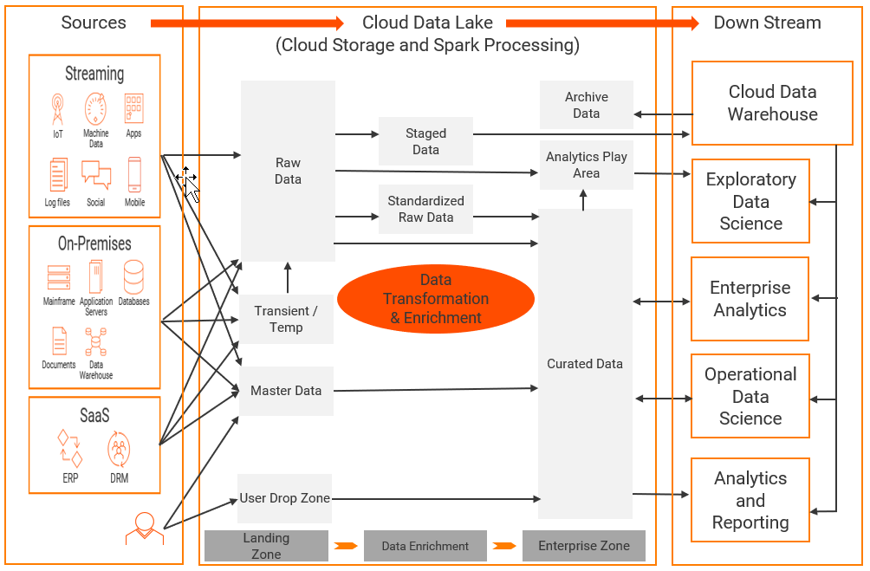

A typical cloud data lake can be split into several logical zones:
- Raw Data Zone –store data in native format without transformation or binding to any business rules
- Transient/Temp Zone –hold ephemeral data, such as temporary copies, streaming spools, or other short-lived data before being ingested
- Master Data Zone – Golden or Reference data
- User Drop Zone –store manually generated data or user uploaded files
- Staged Data Zone – a temporary storage area between the data sources and a data warehouse usually created to quickly extract data from its data sources, minimizing the impact of the sources
- Standardized Raw Data Zone – raw data formatted to usable information before it is analyzed
- Archive Data Zone – where data which is no longer actively used is stored for long term retention
- Analytics Sandbox Zone –a playground / workspace for exploratory data science and analytics
- Curated Data Zone – where cleansed and transformed data is stored for organized and optimal data delivery

The above zones represent different aspects of the data life cycle. The data is processed within the Data Lake (as opposed to taking it outside for processing).

Features of Informatica’s iPaaS
Informatica’s Intelligent cloud services provides a cloud native, enterprise grade data management solution that combines best of breed DI, DQ, and metadata management that is completely automated and has advanced metadata driven AI capabilities.
- Metadata Management: Provides the ability to discover, govern, and apply data controls across the entire architecture using AI and ML capabilities that have been built on a layer of common enterprise metadata.
- Data Ingestion: The ability to ingest data at any speed, using scalable streaming, database and file ingestion capabilities with comprehensive and highly performant connectivity for batch, near real time, and real time data into the cloud data lake.
- Data Integration and Data Quality: Provides a comprehensive data integration and data quality platform to combine, parse, transform, and cleanse data using a highly scalable and performant data processing engine such as Apache Spark.
- Connectivity: The ability to connect to varied sources including, but not limited to, On-Premise sources like legacy data warehouse, Mainframe, and documents and Streaming sources like IoT, mobile, Social, etc., SaaS, and ERP Applications.
- Next Generational: Independent, cloud native, microservices based and API driven. Supports multi cloud architectures, thereby future proofing next generation architectures from a rapidly changing landscape.

